Asia-China-Coin-Knife-Needle Tip-Mould-H 4.8 var. R 5

Knife money evolved contemporaneously with spade money in the northeast of China and can be equated with actual knives used during the Zhou Dynasty (1046–256 BCE). This had been an area of the Neolithic Hongshan Culture and examples of jade knife money are known to have existed.

The Type 2 Needle Tip Knife (of which this is a mould) was first discovered in an excavation in 1932 at Chengde (承德, [40°58′N 117°56′E](http://tools.wmflabs.org/geohack/geohack.php?pagename=Chengde&params=40_58_N_117_56_E_type:city(3610000)_region:CN-13)), Hebei Province (previously known as **Jehol** or Rèhé**,** 熱河**)**. Other excavations in Chengde County have uncovered more examples. In the late Zhou Dynasty the northeast China was within the orbit of the Xiongnu (Huns) and it has been suggested that these Needle Tip money knives were used for trade by the Chinese with them. This is further supported by the fact that there are unusual characters on many of these knives which may be in the Hunnish language. If so, this type of money would represent an economic acculturation of the Chinese with foreign trading neighbors who were otherwise enemies.

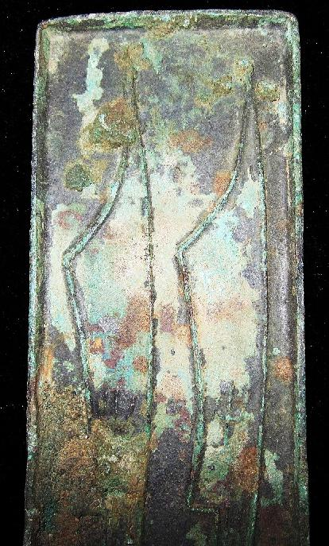

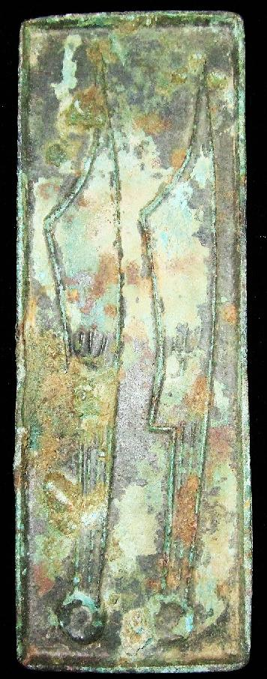

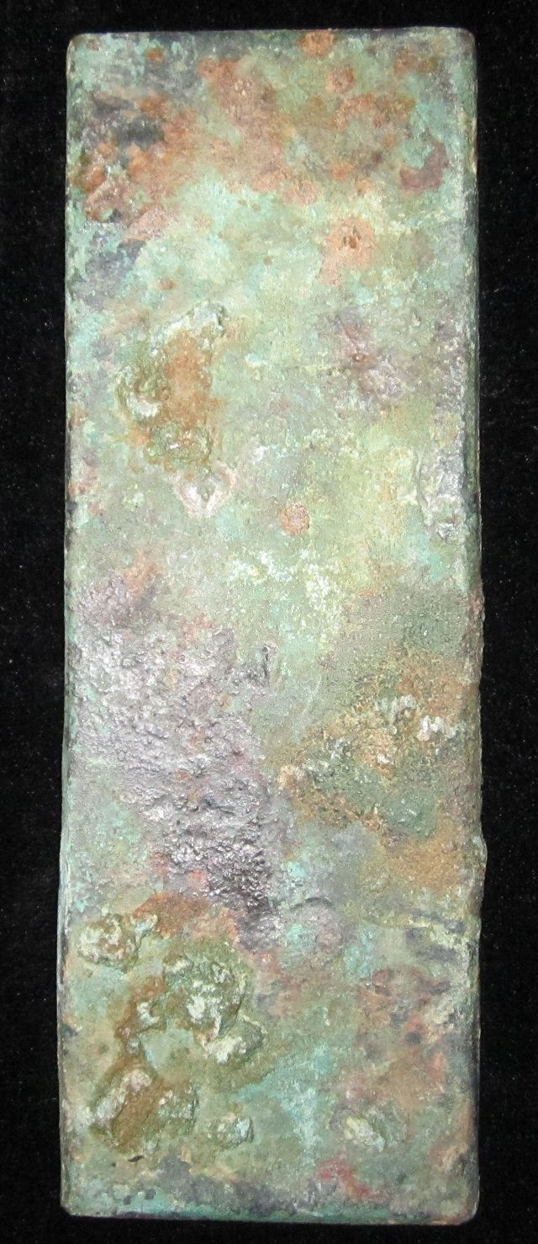

Order details Printer friendly page

Sold by

[bcculture](http://myworld.ebay.com/bcculture) ( [81](http://feedback.ebay.com/ws/eBayISAPI.dll?ViewFeedback&userid=bcculture)  )

+ Show additional actions

Delivery package 1 of 1

Estimated delivery Friday, Jan 17, 2014 - Wednesday, Feb 5, 2014

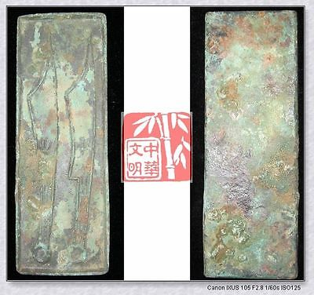

[WARRINGSTATESPERIOD YAN NATION MINT MONEY MODEL BRONZE FALCION COIN PATTERN针首刀6"](http://www.ebay.com/itm/251391538342)

Item price

$79.99

Quantity

1

Item number

251391538342

Shipping service

Economy Shipping from outside US

[Leave feedback](http://feedback.ebay.com/ws/eBayISAPI.dll?LeaveFeedbackShow&useridfrom=802-867&useridto=bcculture&item=251391538342&transactid=1360128554015) [Contact seller](http://contact.ebay.com/ws/eBayISAPI.dll?FindAnswers&frm=3998&iid=251391538342&redirect=0&requested=bcculture) [Return item](http://return.ebay.com/ws/eBayISAPI.dll?ResolveReturn&eventName=viewSelectedItem&TransactionId=1360128554015&ItemId=251391538342)

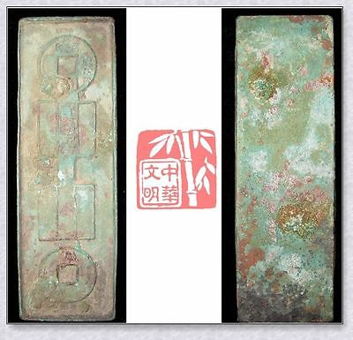

[VINTAGE HAN XINMANG TIME ￥10000 MONEY MODEL BRONZE FALCHION COIN PATTERN国宝金匮直万6"](http://www.ebay.com/itm/251396289678)

Item price

$69.99

Quantity

1

Item number

251396289678

Shipping service

Economy Shipping from outside US

[Leave feedback](http://feedback.ebay.com/ws/eBayISAPI.dll?LeaveFeedbackShow&useridfrom=802-867&useridto=bcculture&item=251396289678&transactid=1360163231015) [Contact seller](http://contact.ebay.com/ws/eBayISAPI.dll?FindAnswers&frm=3998&iid=251396289678&redirect=0&requested=bcculture) [Return item](http://return.ebay.com/ws/eBayISAPI.dll?ResolveReturn&eventName=viewSelectedItem&TransactionId=1360163231015&ItemId=251396289678)

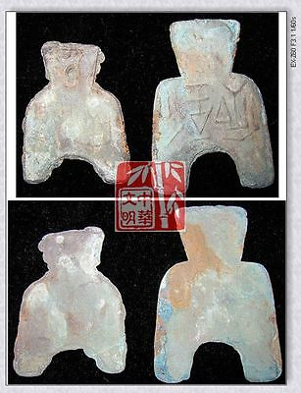

[WarringStatesPeriod WEI NATION CAPITAL MINT WEIGHT MONEY BRONZE SPADE COIN虞*釿SET](http://www.ebay.com/itm/251413448140)

Item price

$69.99

Quantity

1

Item number

251413448140

Shipping service

Economy Shipping from outside US

[Leave feedback](http://feedback.ebay.com/ws/eBayISAPI.dll?LeaveFeedbackShow&useridfrom=802-867&useridto=bcculture&item=251413448140&transactid=1360205391015) [Contact seller](http://contact.ebay.com/ws/eBayISAPI.dll?FindAnswers&frm=3998&iid=251413448140&redirect=0&requested=bcculture) [Return item](http://return.ebay.com/ws/eBayISAPI.dll?ResolveReturn&eventName=viewSelectedItem&TransactionId=1360205391015&ItemId=251413448140)

### Shipping address

Ralph J Coffman Jr  
149 Atlantic Ave   
Swampscott MA 01907-2427  
United States

Phone number  
781 584 7091

### Order total

Subtotal $219.97

Shipping $80.00

Discount -$15.00

#### Total

## $284.97

[View PayPal transaction](http://payments.ebay.com/ws1/eBayISAPI.dll?IntermediateResolutionInfo&itemid=0&transId=0&pn=UnifiedCheckoutSummaryRedirect2PP&qs=itemid%3D0%26transId%3D0%26buyerorseller%3D0%26)

### Order information

Order placed on  
Sunday, Dec 29, 2013

Having a problem with this purchase?  
[Resolve problem](http://res.ebay.com/ws/eBayISAPI.dll?ResolutionCenter)

Payment method   
PayPal

Payment date  
Sunday, Dec 29, 2013